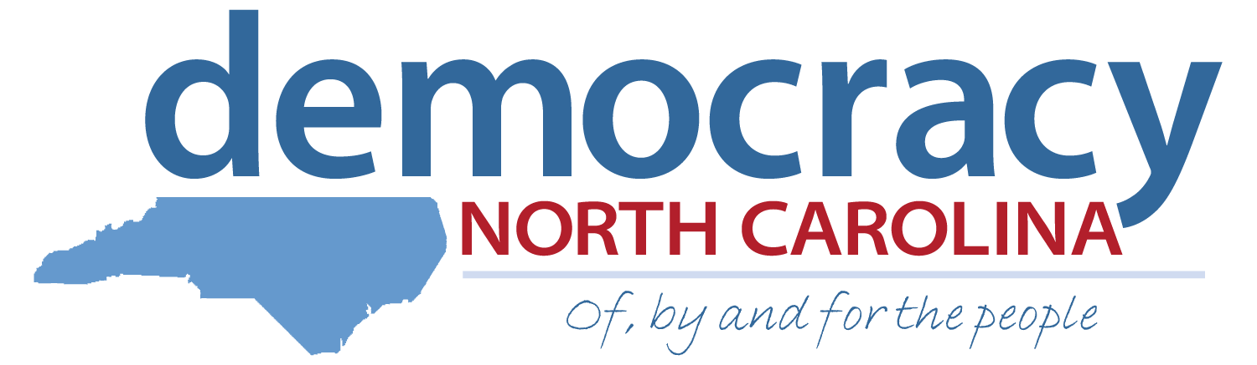
Research Intern Application Democracy Summer 2015
Deadline: April 3, 2015

We are the Ones We’ve Been Waiting For…
June Jordan

Democracy North Carolina is a nonpartisan organization that uses research, organizing, and advocacy to increase voter participation, reduce the influence of big money in politics and achieve a government that is truly of, by and for the people. Built on the legacy of Freedom Summer, the Democracy Summer program has provided a life-changing community organizing experience for students from colleges across the state since 2000.

The Research Intern will conduct policy and advocacy research to advance Democracy NC’s priority campaigns, and work closely with the Communications Intern to translate our substantive work into accessible, public education materials.

Additionally, the Research Intern will develop a work plan, learn the basics of advocacy-oriented research and policy work including gathering and synthesizing information from multiple sources, communicate with community members to gather intelligence, and assist with the development of public education materials in a variety of forms. They will gain skills that will serve them throughout their lives -- policy research and writing, translating elections law jargon into accessible materials for community members, and on-the-ground intelligence gathering in the communities where we work. At the end of their experience, the intern will provide a Presentation of Learning that highlights their work and learning.

Personal Information:

First Name: _______________________ Last Name: _______________________
Current Address: _____________________________________________________
City: _____________________ State: _______ Zip: ________________
Permanent Address (if different): ________________________________________
City: _____________________ State: _______ Zip: ________________
Primary Phone: (_____) _____________ Other Phone: (_____) _____________
Email: _________________________________
School: _____________________
Expected Month/Year of Graduation: _________ GPA: _________
Will you be taking summer school classes this year? (If yes, you are NOT eligible for Democracy Summer and STOP filling out the application.)
 Yes  No
Do you have a valid driver’s license?
 Yes  No

IMPORTANT: The hiring process consists of two rounds. If selected for the first round, you will schedule a phone interview sometime between April 10 – April 17. The final round consists of a full day of individual and group interviews in Durham, NC on Saturday, April 25. You must be able to attend 2nd round interviews if selected. Applicants who travel more than 30 miles to the in-person interview will be reimbursed for mileage.
How did you hear about Democracy Summer? (Please check all that apply)
 Academic Department Email  I saw a flier or poster on campus
 Internship or Job Fair  Professor at my school
 University Career Center  Democracy Summer Alumni
 Democracy NC presentation to my class  Newspaper/ On-line Ad
Other (Please specify):

Please indicate the programs with which you are familiar:
 Intermediate Excel or other spreadsheet programs

 Social Media (Facebook, Twitter, Instagram, etc.)

 Advanced Internet research  Access or other databases

 SPSS or other analytical software  ArcGIS

 Digital Storytelling
Other (Please specify):

Essay Questions: Please answer the following questions in 200 words or less. Please attach a separate sheet of paper if necessary.
- List the political and/or social justice issue (s) that you are most passionate about and how they affect you and your generation. In your response please indicate how research and advocacy intersects with these issues.

- Find the January 2014 issue brief on online voter registration via the National Conference on State Legislatures website. Read the issue brief and provide a brief analysis of how the adoption of online voter registration in North Carolina might affect college students, considering the implications for both in-state and out-of-state students, as well as students from various racial, ethnic, and class backgrounds. Click here…. http://www.ncsl.org/research/elections-and-campaigns/electronic-or-online-voter-registration.aspx

- What does being part of a team mean to you? Describe an experience where working as part of a team taught you about your own individual strengths.

4. What does leadership and accountability mean to you? Please describe the characteristics you feel are important to exemplify in a full-time leadership role.

References:

Please list the names and phone numbers for three references we may consult about your employment, activities or education. References may include current or former supervisors, teachers, co-workers, community leaders, etc. Please do not include relatives or friends.

Name: ____________________________ Phone: (_____) _____________

Email: ______________________ Relationship: ______________________

Name: ____________________________ Phone: (_____) _____________

Email: ______________________ Relationship: ______________________

Name: ____________________________ Phone: (_____) _____________

Email: ______________________ Relationship: ______________________

Certification:

I, __________________________________________ (insert full name), have read and understood the eligibility requirements and expectations for the Democracy Summer program and certify that all the information I have provided in this application is accurate and true.

Signature: ______________________ Date: ______________________

Please return this application, your resume and a cover letter by Friday, April 3rd to:

Attn:
Democracy Summer Program
info@democracy-nc.org

Or mail application materials to:

Democracy Summer Program
c/o Democracy North Carolina
1821 Green St.
Durham, NC 27705

