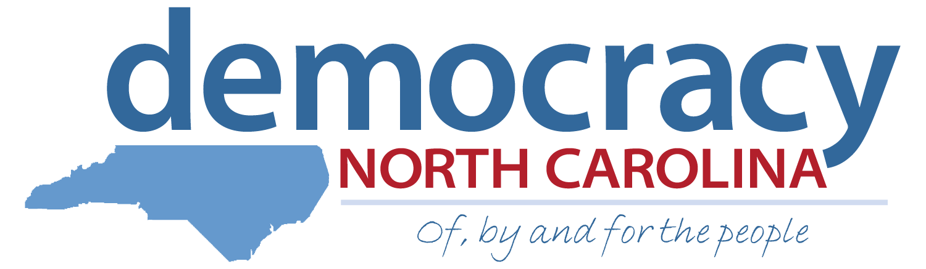

Organizing Intern Application: Democracy Summer 2015
Deadline: April 3, 2015

We are the Ones We’ve Been Waiting For…
June Jordan

Democracy North Carolina is a nonpartisan organization that uses research, organizing, and advocacy to increase voter participation, reduce the influence of big money in politics and achieve a government that is truly of, by and for the people. Built on the legacy of Freedom Summer, the Democracy Summer program has provided a life-changing community organizing experience for students from colleges across the state since 2000.

As an Organizing Intern, participants engage in placed-based direct action organizing in teams of two under the supervision of one of our highly skilled and experienced community organizers. Organizing teams will work in local communities in Asheville, Charlotte, Fayetteville, Rocky Mount or Winston-Salem to empower local volunteers, advocate for policies that improve democracy, and understand how to navigate North Carolina’s power structure and political process.

Additionally, an Organizing Intern will develop a work plan, learn the basics of grassroots organizing, and engage in a variety of strategies for civic engagement. They gain skills that will serve them throughout their lives, from public speaking to facilitating meetings, as well as a greater respect for the wisdom of the people in the communities where they work. At the end of the experience, each team provides a Presentation of Learning that highlights their work and learning. Democracy Summer is developing the next generation of social justice advocates.

Personal Information:

First Name: _______________________ Last Name: _______________________

Current Address: _____________________________________________________

City: _____________________ State: _______ Zip: ________________

Permanent Address (if different): ________________________________________

City: _____________________ State: _______ Zip: ________________

Primary Phone: (_____) _____________ Other Phone: (_____) _____________

Email: _________________________________ School: _____________________

Expected Month/Year of Graduation: _________ GPA: _________

Will you be taking summer school classes this year? (If yes, you are NOT eligible for Democracy Summer and STOP filling out the application.)

 Yes  No

Do you have a valid driver’s license?

 Yes  No

Location for which you are applying:

Asheville  Charlotte  Fayetteville  Winston Salem  Rocky Mount

IMPORTANT: The hiring process consists of two rounds. If selected for the first round, you will schedule a phone interview sometime between April 10 – April 17. The final round consists of a full day of individual and group interviews in Durham, NC on Saturday, April 25. You must be able to attend 2nd round interviews if selected. Applicants who travel more than 30 miles to the in-person interview will be reimbursed for mileage.

How did you hear about Democracy Summer? (Please check all that apply)

 Academic Department Email or email from professor
 I saw a flier or poster on campus
 University Career Center  Democracy Summer Alumni
 Dem NC presentation to my class  Social media

Other (Please specify):

Please indicate the programs with which you are familiar:
 Microsoft Word  Excel or other spreadsheet programs
 HTML (editing software)  Social Media (Facebook, Twitter, Google+, etc)
 Advanced Internet research
 Media Arts (documentary studies, digital theater, communications, design, etc.)
Other (Please specify):
Essay Questions: Please answer the following questions in 200 words or less. Please attach a separate sheet of paper if necessary.
1. List the political and/or social justice issue (s) that you are most passionate about and your perspective on how they affect you and your generation.

2. Please share with us two real-life examples of things you have done to 1) address one or more of the issues above, or 2) to improve your community or 3) to promote social change. These examples may be from activities you participated in through school, a religious institution, a community organization, or from work you initiated and conducted on your own.

3. What does being part of a team mean to you? Describe something you have learned from working with a team to accomplish a task. What do you think your greatest contribution to the team was, what was your biggest challenge in working with the team and what did you learn about yourself and the process in both instances?

4. What does leadership and accountability mean to you? Please describe the characteristics you feel are important to exemplify in a full-time leadership role.

References:

Please list the names and phone numbers for three references we may consult about your employment, activities or education. References may include current or former supervisors, teachers, co-workers, community leaders, etc. Please do not include relatives or friends.

Name: ____________________________ Phone: (_____) _____________

Email: ______________________ Relationship: ______________________

Name: ____________________________ Phone: (_____) _____________

Email: ______________________ Relationship: ______________________

Name: ____________________________ Phone: (_____) _____________

Email: ______________________ Relationship: ______________________

Certification:

I, __________________________________________ (insert full name), have read and understood the eligibility requirements and expectations for the Democracy Summer program and certify that all the information I have provided in this application is accurate and true.

Signature: ______________________ Date: ______________________

Please return this application, your resume and a cover letter by Friday, April 3rd

Attn:
Democracy Summer Program
info@democracy-nc.org

Or mail application materials to:

Democracy Summer Program
c/o Democracy North Carolina
1821 Green St.
Durham, NC 27705

