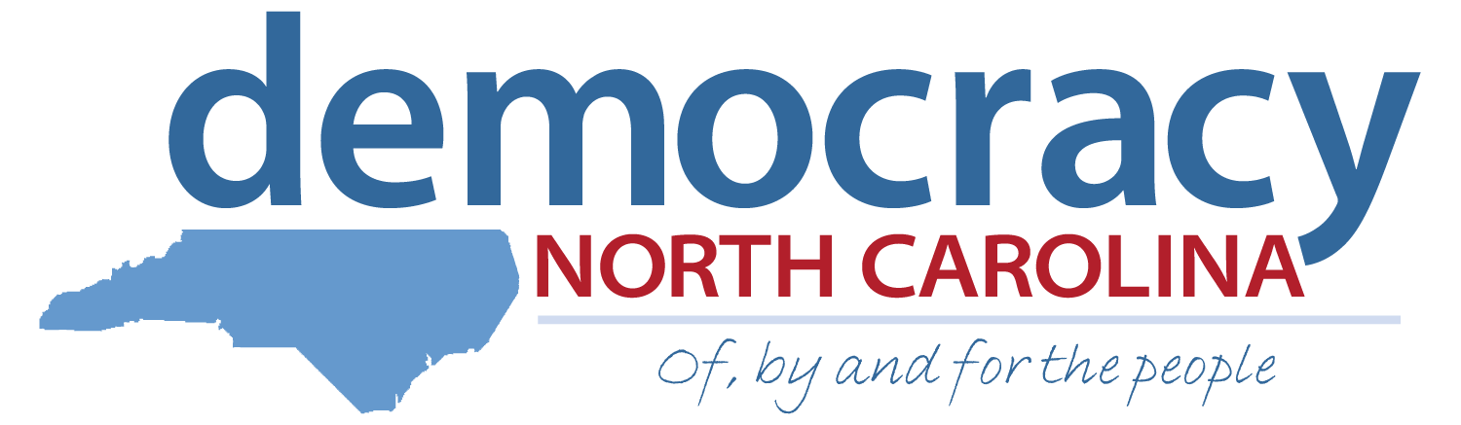

Communications Intern Application Democracy Summer 2015

Deadline: April 3, 2015

We are the Ones We’ve Been Waiting For…
June Jordan

Democracy North Carolina is a nonpartisan organization that uses research, organizing, and advocacy to increase voter participation, reduce the influence of big money in politics and achieve a government that is truly of, by and for the people. Built on the legacy of Freedom Summer, the Democracy Summer program has provided a life-changing community organizing experience for students from colleges across the state since 2000.

The communications intern will work from our main office located in Durham, NC under the supervision of our Communications Specialist. The communications intern has a wide range of duties in different areas, including copywriting, graphic and web design and online outreach and advocacy, all related to advancing Democracy NC’s work across the state.

Additionally, the communications intern will develop a work plan and learn the basics of online organizing, including materials development, media relations, social media outreach, and radical media arts, and how it all intersects with on-the-ground organizing. They will gain skills that will serve them throughout their lives, from public speaking to individual time management, as well as a better understanding of available methods for reaching diverse communities. At the end of their experience, the intern will provide a Presentation of Learning that highlights their work and learning.

Personal Information:

First Name: _______________________ Last Name: _______________________

Current Address: _____________________________________________________

City: _____________________ State: _______ Zip: ________________

Permanent Address (if different): ________________________________________

City: _____________________ State: _______ Zip: ________________

Primary Phone: (_____) _____________ Other Phone: (_____) _____________

Email: _________________________________

School: _____________________ Expected Month/Year of Graduation: _________

GPA: _________

Will you be taking summer school classes this year? (If yes, you are NOT eligible for Democracy Summer and STOP filling out the application.)

 Yes  No

Do you have a valid driver’s license?

 Yes  No

IMPORTANT: The hiring process consists of two rounds. If selected for the first round, you will schedule a phone interview sometime between April 10 – April 17. The final round consists of a full day of individual and group interviews in Durham, NC on Saturday, April 25. You must be able to attend 2nd round interviews if selected. Applicants who travel more than 30 miles to the in-person interview will be reimbursed for mileage.

How did you hear about Democracy Summer? (Please check all that apply)

 Academic Department Email  I saw a flier or poster on campus
 Internship or Job Fair  Professor at my school
 University Career Center  Democracy Summer Alumni
 Democracy NC presentation to my class  Newspaper/ On-line Ad

Other (Please specify):

Please indicate the technologies with which you are familiar:
 Microsoft Office Suite  Web analytics
 Google Docs  Social media analytics  CRM software  Social media management tools
Other (Please specify):
Please rate your familiarity with the following:
Adobe Photoshop  Very  Somewhat  Not familiar
Adobe Illustrator  Very  Somewhat  Not familiar
Adobe Dreamweaver  Very  Somewhat  Not familiar
Wordpress  Very  Somewhat  Not familiar
HTML/CSS  Very  Somewhat  Not familiar
Javascript/jQuery  Very  Somewhat  Not familiar
Media Arts  Very  Somewhat  Not familiar
(Digital Storytelling, video production, documentary studies, audio, etc.)

Essay Questions: Please answer the following questions in 200 words or less. Please attach a separate sheet of paper if necessary.
- List the political and/or social justice issue (s) that you are most passionate about and how they affect you and your generation.

- How do you think engaging in advocacy and elections may benefit a nonprofit group working on issues like the ones you listed above? What do you think is the role of communications, messaging and social media in these efforts?

3. What does being part of a team mean to you? Describe an experience where working as part of a team taught you about your own individual strengths.

- What does leadership and accountability mean to you? Please describe the characteristics you feel are important to exemplify in a full-time leadership role.

References:

Please list the names and phone numbers for three references we may consult about your employment, activities or education. References may include current or former supervisors, teachers, co-workers, community leaders, etc. Please do not include relatives or friends.

Name: ____________________________ Phone: (_____) _____________

Email: ______________________ Relationship: ______________________

Name: ____________________________ Phone: (_____) _____________

Email: ______________________ Relationship: ______________________

Name: ____________________________ Phone: (_____) _____________

Email: ______________________ Relationship: ______________________

Certification:

I, __________________________________________ (insert full name), have read and understood the eligibility requirements and expectations for the Democracy Summer program and certify that all the information I have provided in this application is accurate and true.

Signature: ______________________ Date: ______________________

Please return this application, your resume and a cover letter by Friday, April 3rd to:

Attn:
Democracy Summer Program
info@democracy-nc.org

Or mail application materials to:

Democracy Summer Program
c/o Democracy North Carolina
1821 Green St.
Durham, NC 27705

